Student Name: Rakyan Adhikara

Student ID: 219548135

Tash M3.T1P

Activities: MPI Matrix Multiplication

Analysis on runtime:

|  |  |  |  |  |  |
| --- | --- | --- | --- | --- | --- |
|  | 100 | 200 | 300 | 400 | 500 |
| MPI | 0.003534 | 0.027611 | 0.109226 | 0.228469 | 0.45904 |
| MPI / OpenMP* | 0.003399 | 0.010209 | 0.035126 | 0.083417 | 0.193429 |
| MPI / OpenCL | 0.003568 | 0.020871 | 0.086666 | 0.154941 | 0.36795 |

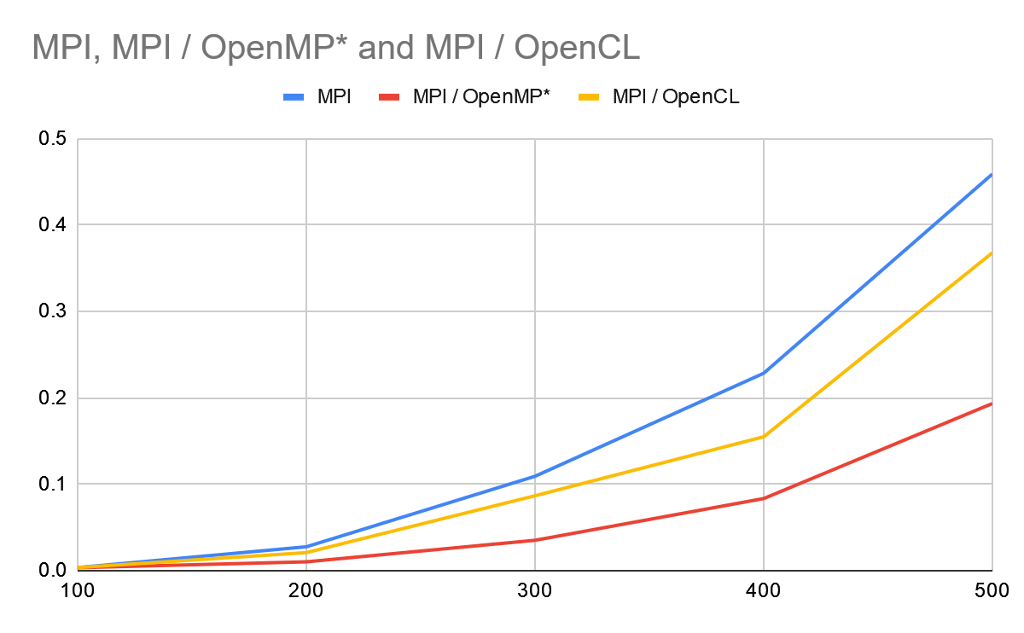

Note: OpenMP runs in 3 thread on this case

Based on my analysis, Hybrid of MPI / OpenMP runs faster than MPI and Hybrid MPI / OpenCL considering it’s a hybrid, then Hybrid MPI / OpenCL and lastly, MPI only. It shows that the benefits of hybrid programming, which makes the runtime faster compared with only one parallel programming. The runtime increases at speed of O(n^2) considering that it’s a matrix multiplication.